**SAS studio: uploading data files and downloading results**

Philip Dixon, Fall 2024

These instructions were checked on my Windows 10 PC using a Firefox browser. Other operating systems and browsers may need some alterations.

SAS Studio runs on servers at the SAS headquarters in North Carolina. Your local computer (laptop or desktop) provides a screen, keyboard, and mouse that talk to a SAS server. That means you have to worry about two different file systems: the local file system on your computer and the file system on the server. These instructions describe how to get files from the class web site onto your computer then uploaded to the SAS server and the reverse process, getting results from the server onto your computer. Once on your computer, you can print, cut and paste into word, or otherwise work with the results.

**Getting files (data or code) from the class web site onto the SAS server:**

* Use a browser to download a file from the class web site.
  + The most reliable way is to right click the link to the file and select “Save link as”
  + This will open a window where you can browse to folder where you want the file saved
  + Any choice of folder will work so long as it’s not a cybox or other cloud folder.
  + Do not change the file extension (the .csv or .txt or .r part of the file name)
  + You can change the file name if you want to, but I recommend you don’t
  + Remember which folder you saved the file in!

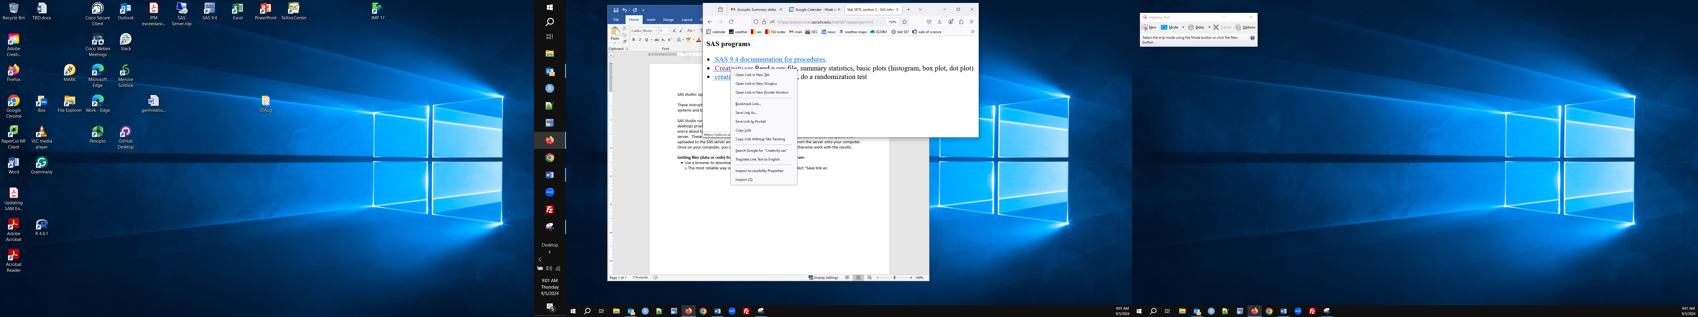

* Start SAS Studio (if not already done)
* Find and write down your userid.
  + Hover the mouse over the sign out button (top right). A popup window will show your userid
* Find the upload button – it’s the fourth button on the top left under Server Files and Folders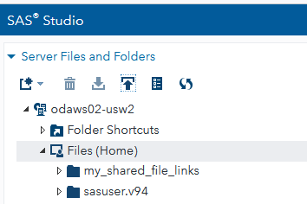
* Click the upload button. The Upload Files window will popup.
* Click Choose files. This opens a window into the file system on your computer.
  + Navigate to where your browser saved your file
* Click the name of the file you want to upload (I’m uploading creativity.csv)
* You should see that file name appear under “Selected Files in that Upload Files window”

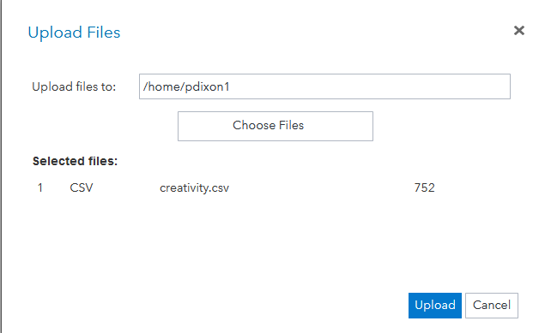

* If you don’t see the file in selected files, SAS Studio couldn’t locate it
  + Some students have had problems with this.
  + My sense is that they were trying to upload a file currently in the cloud, e.g. on CyBox
  + If so, copy the file from your cloud storage to your local file system and upload the local copy
* Click the upload button
* You should see the uploaded file in the list below Files (Home)

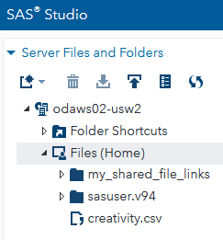

* In the Upload Files window, notice where SAS Studio saved the file on the server
  + This is almost certainly /home/<your userid>. My userid is pdixon1, so the file is in /home/pdixon1
  + You need to specify the full path to the file in order for your code to find it.
  + An alternative (demonstrated later) is to set the default folder to /home/<your userid>



* You can upload the code files (.sas extensions).
  + Same process to upload the file
* Go to the code window, click the mouse in that window to put the cursor in the code window
* type ctrl-o (i.e., hold down the ctrl key while you type o)
  + The Mac equivalent is probably the cloverleaf key-o
  + ctrl-o is the keyboard shortcut for open file. I expect there is a button, but I don’t see that button
* This opens an Open window
  + The first time you do this, you may need to choose a folder
  + If so, click on Files (Home) – you should see the .sas file you uploaded
  + Click on the name of the desired code file
  + Click on the Open Button (bottom right of the open window)
* The contents of the file are added to the code window.
* You can edit this just like in a word processor.

**Things that could go wrong:**

* Your userid is likely to be a seemingly random string of letters and numbers. Copy it down carefully because you’ll need it to write code that finds the folder containing your file.
  + In the Upload Files window, check the folder name (/home/<your userid>).
  + That folder name is what you need to use in code to read a file.
* In lab, someone had trouble uploading files. They selected a local file but it didn’t appear in the Upload Files window. I don’t know what was going wrong, but I suspect they were trying to upload from a cloud folder (e.g. on CyBox). I can thing of reasons why that isn’t possible for the SAS Server to do. If this happens to you, copy the file from the cloud to your local computer, then upload from there.
* If something unusual happens or doesn’t work as expected, try using another browser. In one case, Safari didn’t work but Firefox did.

**Downloading results (tables or figures)**

I know multiple ways to get the contents of the SAS Results window to a file on your local computer

* **Downloading a results file**
  + Use ods rtf to save a copy of the results in a RTF format file on the server
  + See the creativity1.sas explanation document for how to use ods rtf
  + Note: make sure to specify the full path so the file goes in your Files (Home) folder, e.g.:



* + Again, make sure that the file you save has a .rtf extension so the file type (the extenstion) matches the contents (RTF format text and figures).
  + This creates a file on the SAS server. You should see that file appear in the Files (Home) folder
  + Click on file name in the Files (Home) list, then click the Download button (see below)
  + The file will appear in your Downloads folder (at least on a Windows machine)
  + You can open RTF format files in Word and copy figures from there to other documents

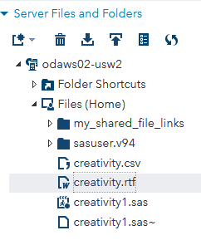

* + There is a button labelled Download Results as an RTF file, but it is greyed out on my system
* **Download results using e-mail**
  + Click on results to view the contents of the results window
  + Click on the email button (the envelope below the word RESULTS)
  + 
* The Send Email window should popup.
  + Fill in your e-mail address, a subject and an (optional) message
  + Make sure HTML results is checked
    - You can also include the code or log by checking those boxes
    - On my system, the PDF results and RTF results boxes are greyed out so I can’t use them
  + Click send
  + When I tried this, it took ca 5 minutes to get from the SAS server to my inbox
* You are sent a .html file with text and images
  + This file can be opened in a browser
  + You can click on a graph to highlight it, then copy it to the clipboard and paste in a Word document
  + (This works in Firefox on my system. I don’t know about other browsers or systems)
* **Downloading results by printing them** 
  + Click on results to view the contents of the results window
  + Click on the print button (the printer icon the word RESULTS)
  + 
  + The popup window allows you to choose a local printer (on or accessible from your computer)
  + If you select “Save to PDF” or “Adobe PDF” or “Microsoft print to PDF”, the results window will be “printed” to a .pdf file.
  + Choose print options (portrait or landscape, select pages, color or B/W)
  + Click the Save or Print button (which depends on which device you selected)
  + This opens a window to select a folder and file name to save the “printed” output
  + These are folders and a file on your local computer.
  + You can open the .pdf file in Acrobat or Acrobat Reader (free), then click on a figure to copy it to a Word document